20CYS 282-User Interface Design

GATE PASS MANAGEMENT SYSTEM

# KAVALI SAI SUVARCHALA

# CB.EN.U4CYS21030

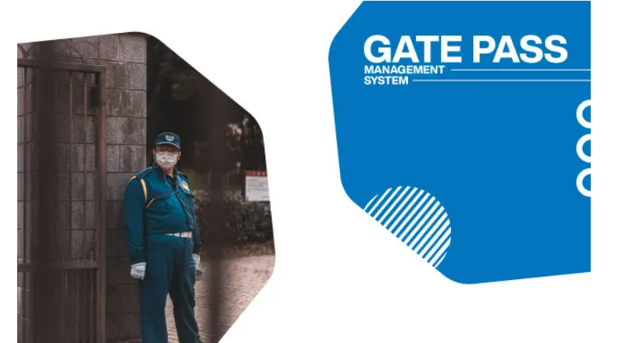

* Gate Pass Management System manages the entry and exit of all students,employees,visitors,vehicles and its an easy way to keep a track on all the vehicles and peoples entry and exit.
* It keeps an eye on every vehicle and its entry and exit timings along with vehicle number and if it is a visitor he should have to apply for a visitor pass along with his personal details like name email and contact number and purpose of his visit ,then he will be provided with a pass with a number without which he is not allowed inside and he has to carry along with him and even during exit he has to show that pass.
* Gate Pass Management System is a type of security system which keeps an eye on everything inside the campus.It also manages about all incoming items like couriers ,parcels and everything also the outgoing items from the campus.
* For a student or faculty or worker of university to apply pass they have to go the gate pass page and have to provide their ID,email and password for login and if they forget the passwprd they can reset it using their mail ID.And after logging in they can apply pass .Pass is of two types which are home pass and day pass and if they apply pass they have to mention the timings of their entry and exit and if it is for the students they have to mention their purpose of their pass.
* For vehicles and delivery or courier executives they will be given a gate pass with a pass number through which they will be allowed to various places of the campus this is to ensure the security of campus .and this pass can be tracked by the admin system.The person has to show the pass where ever he goes and that will be recorded.
* Anyone who wishes to visit the campus need to apply for a pass and if the pass gets approved they can visit the campus .Any unwanted or mischevious activates done by visitors or outsiders the pass can be restricted.
* To get inside the campus the pass has to be approved and the security checks the pass whether its approved or not and then while entering they have to provide their pass id in the security office and their timings of entry and from then the movement of the visitor can be tracked by the security management .Where ever he goes he has to show his pass and then the information will get update and stored in the security managements database.
* Students or visitors will get an sms and mail regarding their pass status ehrther it is approved or not and they will be getting sms/email regarding their pass includimg their entry and exit timings.
* Through gate pass management profile which is provided of universities students and staff they can view manage and edit or delete the information regarding their pass but the data will be stored in the security managements data base.

REQUIREMENTS:

* In the first page we will have login details with login id,password,and option for forgot password.
* Login and password details have to be entered by the user.
* If it’s a student then the student have to enter their roll number,email id and password ,branch and then apply for the pass ,and for faculties they have to enter the faculty id.
* For visitors they have to enter their name ,place ,contact details like email id,phone number,and their purpose of visit and their entry and exit timings into the campus.
* For applying pass the students have to enter details like their ID,email,phone number and their timings of leaving the campus and coming back and the type of pass like whether it is a home pass or day pass and their reasons of applying pass and they have to submit their pass to class teacher and respective hostel warden.
* They will be given a status of their pass whether it is approved or not and there will be settings option to change their timings or dates and they also have the option to cancel the pass.
* When the pass gets approved the users or appliers will get notified.
* In the profile section they can see the history of the pasess applied and the approval time and date and also their entry and exit timings with date. And They can also see their pasess list.
* All the data will be get updated to the security management.
* The Teacher/Resident Warden will also get an information about the number of students applied for pass and timings with dates .
* The teachers /resident warden in their profiles can view the list of students applied for pass.
* Security Management can see the pasess applied in different catageories like student pass vehicle pass visitors pass etc.

Login Page:

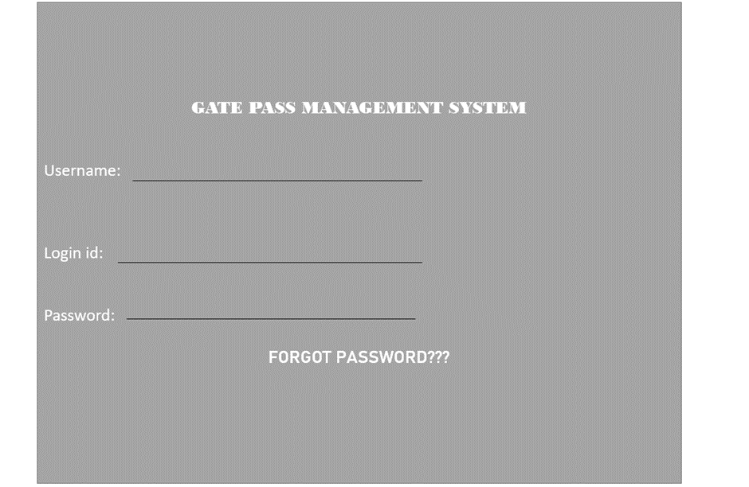

Visitor /Vehicle Pass:

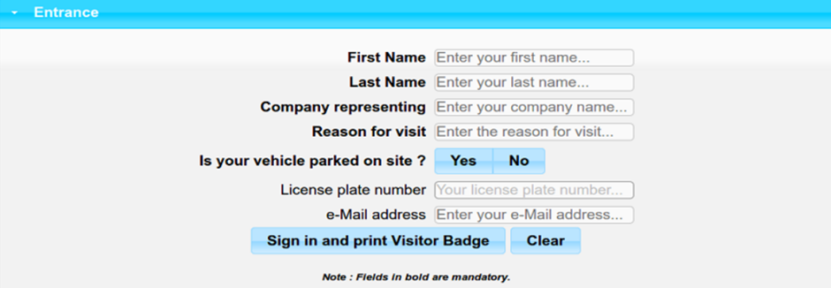

Student Pass:

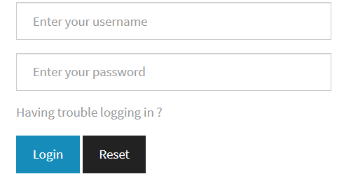

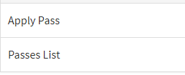

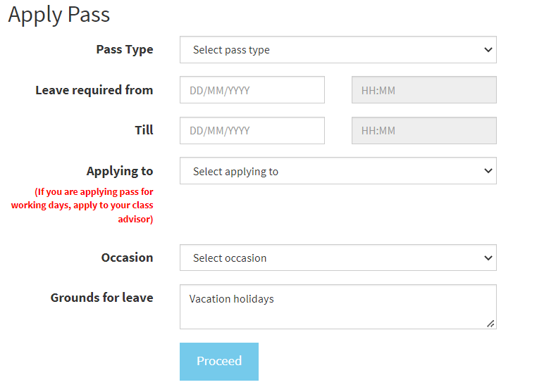

S.No Applied From Applied Till Pass Type Warden Name Acted On By Advisor's Name Advisor's Approval Warden's Approval CFW's Approval Pass Status Applied Time Occasion Reason Pass@month Actual Exit Actual Entry Action

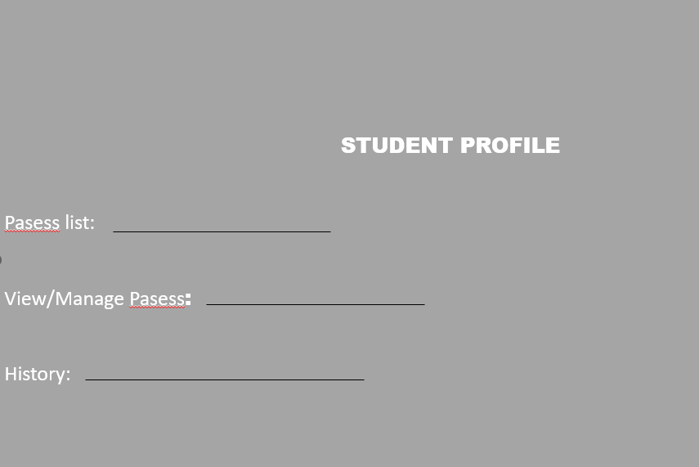

Resident Warden/Teachers view:

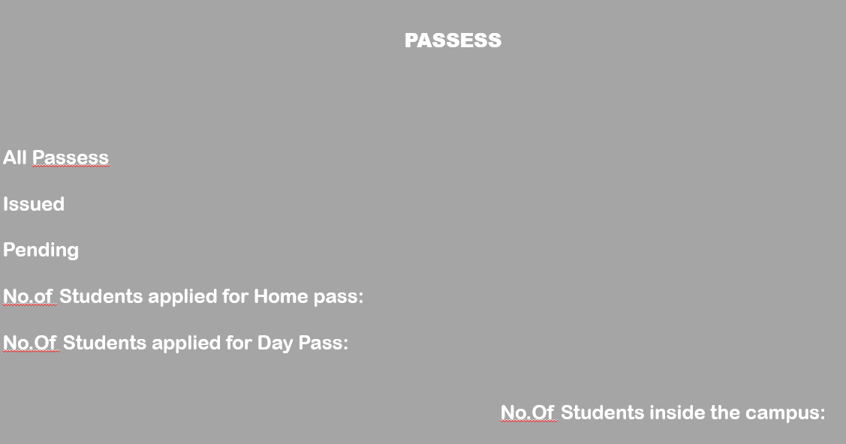

The security management workers/security has to enter their id in the login details and if the security person logs in then he can be able to view all the history related to pasess:

Security Management View:

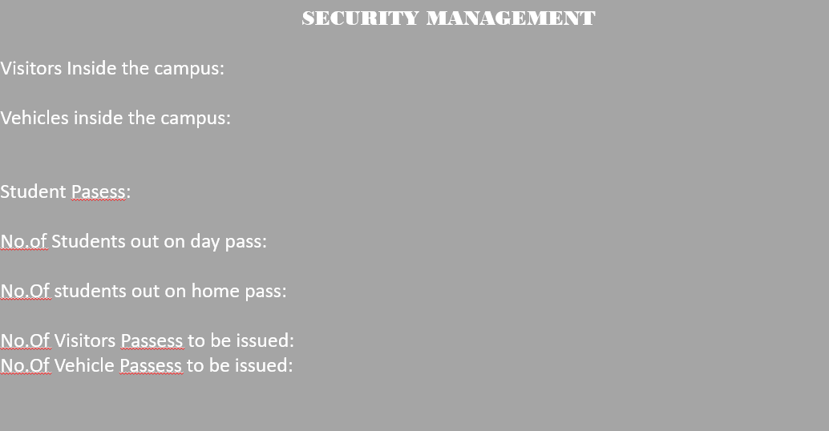

By clicking each one of the above option the security will be able to view all the information regarding the visitors,vehicles,and about the information regarding the type of pass applied by the students.

* If he clicks the visitors inside the campus then he can be able to view all the information regarding the visitors inside the campus.
* If the clicks the vehicles inside the campus then they can be able to view and manageinformation regarding the outside vehicles inside the campus.
* If the clicks student pasess then he can see the no.of pasess issued on the day and their information.
* Accordingly he can view the no.of students out on home and day pass.
* Next if he clicks the visitors passess to be issued he can see complete information regarding the pass applied and it is as same as for vehicles too and so that he can approve the passess.